**Java Project**

**package** StepDefinitions;

**import** java.awt.*;

**import** java.awt.event.*;

**public** **class** MyCalculator **extends** Frame

{

**public** **boolean** setClear=**true**;

**double** number, memValue;

**char** op;

String digitButtonText[] = {"7", "8", "9", "4", "5", "6", "1", "2", "3", "0", "+/-", "." };

String operatorButtonText[] = {"/", "sqrt", "*", "%", "-", "1/X", "+", "=" };

String memoryButtonText[] = {"MC", "MR", "MS", "M+" };

String specialButtonText[] = {"Backspc", "C", "CE" };

MyDigitButton digitButton[]=**new** MyDigitButton[digitButtonText.length];

MyOperatorButton operatorButton[]=**new** MyOperatorButton[operatorButtonText.length];

MyMemoryButton memoryButton[]=**new** MyMemoryButton[memoryButtonText.length];

MySpecialButton specialButton[]=**new** MySpecialButton[specialButtonText.length];

Label displayLabel=**new** Label("0",Label.***RIGHT***);

Label memLabel=**new** Label(" ",Label.***RIGHT***);

**final** **int** FRAME_WIDTH=325,FRAME_HEIGHT=325;

**final** **int** HEIGHT=30, WIDTH=30, H_SPACE=10,V_SPACE=10;

**final** **int** TOPX=30, TOPY=50;

MyCalculator(String frameText)

{

**super**(frameText);

**int** tempX=TOPX, y=TOPY;

displayLabel.setBounds(tempX,y,240,HEIGHT);

displayLabel.setBackground(Color.***BLUE***);

displayLabel.setForeground(Color.***WHITE***);

add(displayLabel);

memLabel.setBounds(TOPX, TOPY+HEIGHT+ V_SPACE,WIDTH, HEIGHT);

add(memLabel);

tempX=TOPX;

y=TOPY+2*(HEIGHT+V_SPACE);

**for**(**int** i=0; i<memoryButton.length; i++)

{

memoryButton[i]=**new** MyMemoryButton(tempX,y,WIDTH,HEIGHT,memoryButtonText[i], **this**);

memoryButton[i].setForeground(Color.***RED***);

y+=HEIGHT+V_SPACE;

}

tempX=TOPX+1*(WIDTH+H_SPACE); y=TOPY+1*(HEIGHT+V_SPACE);

**for**(**int** i=0;i<specialButton.length;i++)

{

specialButton[i]=**new** MySpecialButton(tempX,y,WIDTH*2,HEIGHT,specialButtonText[i], **this**);

specialButton[i].setForeground(Color.***RED***);

tempX=tempX+2*WIDTH+H_SPACE;

}

**int** digitX=TOPX+WIDTH+H_SPACE;

**int** digitY=TOPY+2*(HEIGHT+V_SPACE);

tempX=digitX; y=digitY;

**for**(**int** i=0;i<digitButton.length;i++)

{

digitButton[i]=**new** MyDigitButton(tempX,y,WIDTH,HEIGHT,digitButtonText[i], **this**);

digitButton[i].setForeground(Color.***BLUE***);

tempX+=WIDTH+H_SPACE;

**if**((i+1)%3==0){tempX=digitX; y+=HEIGHT+V_SPACE;}

}

**int** opsX=digitX+2*(WIDTH+H_SPACE)+H_SPACE;

**int** opsY=digitY;

tempX=opsX; y=opsY;

**for**(**int** i=0;i<operatorButton.length;i++)

{

tempX+=WIDTH+H_SPACE;

operatorButton[i]=**new** MyOperatorButton(tempX,y,WIDTH,HEIGHT,operatorButtonText[i], **this**);

operatorButton[i].setForeground(Color.***RED***);

**if**((i+1)%2==0){tempX=opsX; y+=HEIGHT+V_SPACE;}

}

addWindowListener(**new** WindowAdapter()

{

**public** **void** windowClosing(WindowEvent ev)

{System.*exit*(0);}

});

setLayout(**null**);

setSize(FRAME_WIDTH,FRAME_HEIGHT);

setVisible(**true**);

}

**static** String getFormattedText(**double** temp)

{

String resText=""+temp;

**if**(resText.lastIndexOf(".0")>0)

resText=resText.substring(0,resText.length()-2);

**return** resText;

}

**public** **static** **void** main(String []args)

{

**new** MyCalculator("Calculator - JavaTpoint");

}

}

**class** MyDigitButton **extends** Button **implements** ActionListener

{

MyCalculator cl;

MyDigitButton(**int** x,**int** y, **int** width,**int** height,String cap, MyCalculator clc)

{

**super**(cap);

setBounds(x,y,width,height);

**this**.cl=clc;

**this**.cl.add(**this**);

addActionListener(**this**);

}

**static** **boolean** isInString(String s, **char** ch)

{

**for**(**int** i=0; i<s.length();i++) **if**(s.charAt(i)==ch) **return** **true**;

**return** **false**;

}

**public** **void** actionPerformed(ActionEvent ev)

{

String tempText=((MyDigitButton)ev.getSource()).getLabel();

**if**(tempText.equals("."))

{

**if**(cl.setClear)

{cl.displayLabel.setText("0.");cl.setClear=**false**;}

**else** **if**(!*isInString*(cl.displayLabel.getText(),'.'))

cl.displayLabel.setText(cl.displayLabel.getText()+".");

**return**;

}

**int** index=0;

**try**{

index=Integer.*parseInt*(tempText);

}**catch**(NumberFormatException e){**return**;}

**if** (index==0 && cl.displayLabel.getText().equals("0")) **return**;

**if**(cl.setClear)

{cl.displayLabel.setText(""+index);cl.setClear=**false**;}

**else**

cl.displayLabel.setText(cl.displayLabel.getText()+index);

}

}

**class** MyOperatorButton **extends** Button **implements** ActionListener

{

MyCalculator cl;

MyOperatorButton(**int** x,**int** y, **int** width,**int** height,String cap, MyCalculator clc)

{

**super**(cap);

setBounds(x,y,width,height);

**this**.cl=clc;

**this**.cl.add(**this**);

addActionListener(**this**);

}

**public** **void** actionPerformed(ActionEvent ev)

{

String opText=((MyOperatorButton)ev.getSource()).getLabel();

cl.setClear=**true**;

**double** temp=Double.*parseDouble*(cl.displayLabel.getText());

**if**(opText.equals("1/x"))

{

**try**

{**double** tempd=1/(**double**)temp;

cl.displayLabel.setText(MyCalculator.*getFormattedText*(tempd));}

**catch**(ArithmeticException excp)

{cl.displayLabel.setText("Divide by 0.");}

**return**;

}

**if**(opText.equals("sqrt"))

{

**try**

{**double** tempd=Math.*sqrt*(temp);

cl.displayLabel.setText(MyCalculator.*getFormattedText*(tempd));}

**catch**(ArithmeticException excp)

{cl.displayLabel.setText("Divide by 0.");}

**return**;

}

**if**(!opText.equals("="))

{

cl.number=temp;

cl.op=opText.charAt(0);

**return**;

}

**switch**(cl.op)

{

**case** '+':

temp+=cl.number;**break**;

**case** '-':

temp=cl.number-temp;**break**;

**case** '*':

temp*=cl.number;**break**;

**case** '%':

**try**{temp=cl.number%temp;}

**catch**(ArithmeticException excp)

{cl.displayLabel.setText("Divide by 0."); **return**;}

**break**;

**case** '/':

**try**{temp=cl.number/temp;}

**catch**(ArithmeticException excp)

{cl.displayLabel.setText("Divide by 0."); **return**;}

**break**;

}//switch

cl.displayLabel.setText(MyCalculator.*getFormattedText*(temp));

}

}

**class** MyMemoryButton **extends** Button **implements** ActionListener

{

MyCalculator cl;

MyMemoryButton(**int** x,**int** y, **int** width,**int** height,String cap, MyCalculator clc)

{

**super**(cap);

setBounds(x,y,width,height);

**this**.cl=clc;

**this**.cl.add(**this**);

addActionListener(**this**);

}

**public** **void** actionPerformed(ActionEvent ev)

{

**char** memop=((MyMemoryButton)ev.getSource()).getLabel().charAt(1);

cl.setClear=**true**;

**double** temp=Double.*parseDouble*(cl.displayLabel.getText());

**switch**(memop)

{

**case** 'C':

cl.memLabel.setText(" ");cl.memValue=0.0;**break**;

**case** 'R':

cl.displayLabel.setText(MyCalculator.*getFormattedText*(cl.memValue));**break**;

**case** 'S':

cl.memValue=0.0;

**case** '+':

cl.memValue+=Double.*parseDouble*(cl.displayLabel.getText());

**if**(cl.displayLabel.getText().equals("0") || cl.displayLabel.getText().equals("0.0") )

cl.memLabel.setText(" ");

**else**

cl.memLabel.setText("M");

**break**;

}

}

}

**class** MySpecialButton **extends** Button **implements** ActionListener

{

MyCalculator cl;

MySpecialButton(**int** x,**int** y, **int** width,**int** height,String cap, MyCalculator clc)

{

**super**(cap);

setBounds(x,y,width,height);

**this**.cl=clc;

**this**.cl.add(**this**);

addActionListener(**this**);

}

**static** String backSpace(String s)

{

String Res="";

**for**(**int** i=0; i<s.length()-1; i++) Res+=s.charAt(i);

**return** Res;

}

**public** **void** actionPerformed(ActionEvent ev)

{

String opText=((MySpecialButton)ev.getSource()).getLabel();

**if**(opText.equals("Backspc"))

{

String tempText=*backSpace*(cl.displayLabel.getText());

**if**(tempText.equals(""))

cl.displayLabel.setText("0");

**else**

cl.displayLabel.setText(tempText);

**return**;

}

**if**(opText.equals("C"))

{

cl.number=0.0; cl.op=' '; cl.memValue=0.0;

cl.memLabel.setText(" ");

}

cl.displayLabel.setText("0");cl.setClear=**true**;

}

}

**Screenshot:**

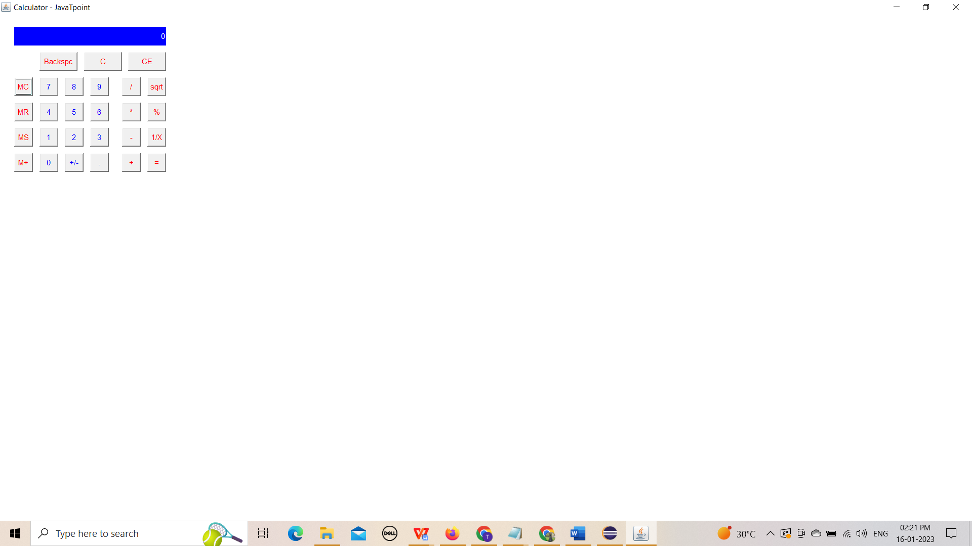

Input= 12*56

